**Assignment No.7**

**Title:-** Write 64-bit ALP to accept the numbers from user and perform addition of 2 numbers and display the result on screen.

Code:-

;ALP for addition of 2 digit numbers

section .data

msg db “Enter two digit Number:”

msg_len equ $-msg

res db 10,”Addition of numbers is:”

res_len equ $-res

section .bss

num resb 03

num1 resb 01

result resb 04

section .text

%macro print 2

mov rax,1 ; Function 1 – write

mov rdi,1 ; To stdout

mov rsi,%1 ; String address

mov rdx,%2 ; String size

syscall ; invoke operating system to WRITE

%endmacro

%macro read 2

mov rax,0 ; Function 0 - Read

mov rdi,0 ; from stdin

mov rsi,%1 ; buffer address

mov rdx,%2 ; buffer size

syscall ; invoke operating system to READ

%endmacro

global _start

_start:

xor rax,rax

xor rbx,rbx

xor rcx,rcx

xor rdx,rdx

mov byte[result],0

mov byte[num],0

mov byte[num1],0

print msg, msg_len

read num,3

call convert

mov [num1],bl

print msg, msg_len

read num,3

call convert

xor rcx,rcx

xor rax,rax

mov rax,[num1]

add rax, rbx

mov [result],rax

print res, res_len

mov rbx,[result]

call display

mov rax,60

mov rdi,0

syscall

convert: ;; ASCII to Hex conversion

xor rbx,rbx

xor rcx,rcx

xor rax,rax

mov rcx,02

mov rsi,num

up1:

rol bl,04

mov al,[rsi]

cmp al,39h

jbe p1

sub al,07h

jmp p2

p1: sub al,30h

p2: add bl,al

inc rsi

loop up1

ret

display: ;; Hex to ASCII conversion

mov rcx,4

mov rdi,result

dup1:

rol bx,4

mov al,bl

and al,0fh

cmp al,09h

jbe p3

add al,07h

;jmp p4

p3: add al,30h

p4:mov [rdi],al

inc rdi

loop dup1

print result,4

ret

OUTPUT:-

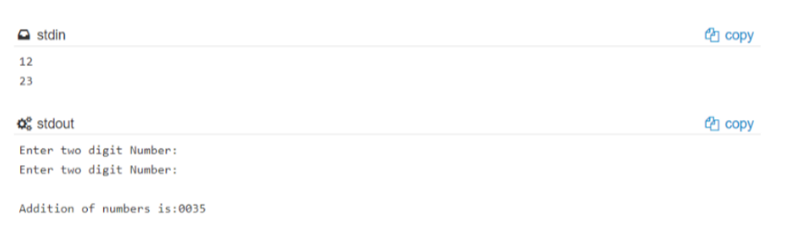

**Name**: Yashraj Vijay Aware

**Division**: D1

**Roll No**:224006

**Prn No**: 22110167